Practical 31-32 :

Code :

import java.io.\*;

public class Copy {

    public static void main(String[] args) {

        try{

        File source = new File( "D:\\Diploma Sem 4\\Subjects\\java\\PRACTICALS\\31-32\\f1.txt");

        File destination = new File("D:\\Diploma Sem 4\\Subjects\\java\\PRACTICALS\\31-32\\f2.txt");

        FileInputStream inputStream = new FileInputStream(source);

        FileOutputStream outputStream = new FileOutputStream(destination);

        int length = (int) source.length();

        byte[] buffer = new byte[length];

        while ((length = inputStream.read(buffer)) > 0) {

            outputStream.write(buffer, 0, length);

        }

        inputStream.close();

        outputStream.close();

        System.out.println("File copied successfully.......");

    }catch(Exception e){

        System.out.println("Exeption Occured");

    } }}

Output :

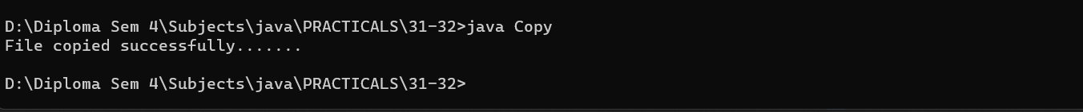

F1 :

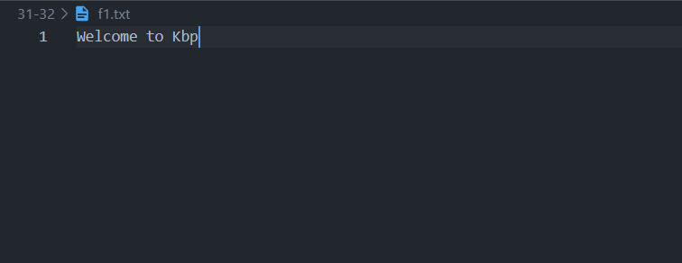

F2 :

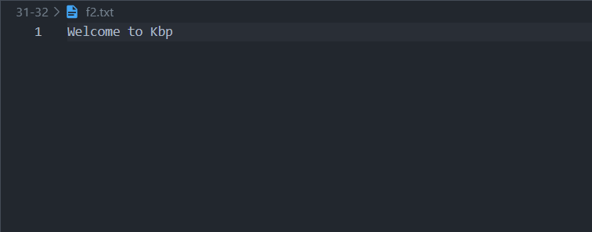

Code :

import java.io.File;

import java.io.FileOutputStream;

public class Byt {

    public static void main(String args[]){

        File file = new File("D:\\Diploma Sem 4\\Subjects\\java\\PRACTICALS\\31-32\\f3.txt");

        try {

            try (FileOutputStream fout = new FileOutputStream(file)) {

                String s = "Example of Java program to write Bytes using ByteStream.";

                byte b[] = s.getBytes();

                fout.write(b);

                System.out.println("Done !!");

            }

        }catch (Exception e){

            e.printStackTrace();

        }

    }

}

Output :

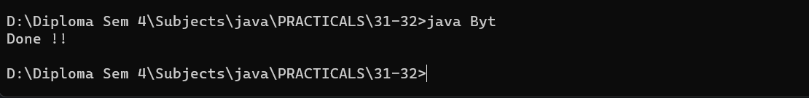

F3 :

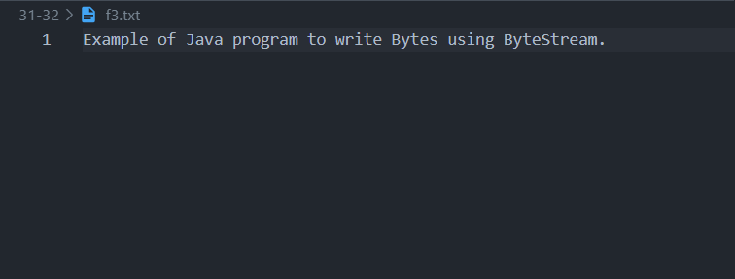

Code :

import java.io.\*;

class Displ{

 public static void main(String[] args){

  try{

    FileWriter myWriter = new FileWriter("D:\\Diploma Sem 4\\Subjects\\java\\PRACTICALS\\31-32\\f4.txt");

    myWriter.write(args[0]);

    myWriter.close();

  }

  catch(Exception e)

  {}

 }

}

Output :

